PROJECT REPORT SUMMARY
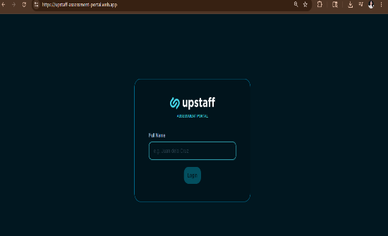
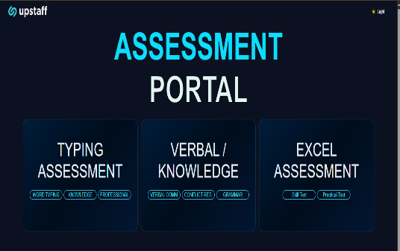

Website: https://upstaff-assessment-portal.web.app
Sheet: https://docs.google.com/spreadsheets/d/1uBeZjXNuj3-mipo_klfM1n4fMJBhOEf8iMwY_z74s9E/edit?usp=sharing

Project Title
Upstaff Assessment Portal
Purpose of the Project
Before this project, Applicants had to visit Monkey Type, an external website, just to take a typing test. The purpose of this project is to give Upstaff its own assessment website so applicants no longer need to do it in an old way.
Project Objectives
Replace Monkey Type with a typing assessment that Upstaff owns. Add a Knowledge Test and a Conflict Resolution Test to evaluate applicants more thoroughly. Store all results in a Google Sheet that the HR team can access directly.
Scope of the Project
The portal covers three assessments: Typing, Knowledge/Verbal, and Excel Assessment. Results are saved automatically to Google Sheets.
Target Users
Job applicants who take the assessments as part of the upstaff hiring process, and the upstaff HR team who reviews their results through the connected Google Sheet.

Project Overview / Description
The Upstaff Assessment Portal is a website built for upstaff to conduct pre-employment assessments. Applicants visit the site to take a Typing Test with different time limits and difficulty levels, a Knowledge Test covering grammar and comprehension, and a Conflict Resolution Test and Excel Skill Test. All results are automatically logged to a Google Sheet the HR team can view.
Methodology or Process Used
The project was built by designing the layout based on upstaff branding, developing each assessment module one at a time, writing the test content, connecting results to Google Sheets, and deploying through Firebase Hosting.
Systems, Tools, or Technologies Used
The portal was built using HTML, CSS, and JavaScript. It is hosted on Firebase Hosting. Google Sheets is used as the results database where all applicant scores are stored and can be accessed by HR at: https://docs.google.com/spreadsheets/d/1uBeZjXNuj3-mipo_klfM1n4fMJBhOEf8iMwY_z74s9E
Key Features or Functions
The Typing Assessment supports time limits from 30 seconds to 5 minutes and includes difficulty levels from Easy to Professional, with subtopics like Legal, Medical, and Coding. There is also a Knowledge Test, a Grammar Test, and a Conflict Resolution Test. All results are saved automatically to Google Sheets after each submission.
Challenges Encountered
The main challenges were building the real-time typing engine from scratch, writing test content across multiple topics and difficulty levels, and connecting the portal to Google Sheets so results are saved automatically after each test.

Project Outcomes or Results
The portal is live and fully working. Upstaff no longer relies on Monkey Type. Three assessments are now available instead of just one. All applicant results are saved automatically to Google Sheets for HR to review anytime.
Skills and Knowledge Gained
This project helped develop skills in web development, Firebase deployment, Google Sheets integration, UI design, and writing assessment content for different skill levels.
Contribution to Upstaff
Upstaff now has an assessment platform it fully owns and controls. The HR team can view all applicant results in one Google Sheet with no manual work needed. The portal can also be expanded in the future with additional tests Assessment.
Recommendations and Conclusions
The next step would be to enhance the Excel Assessment module that is already planned. Adding more test content over time would also help keep the assessments relevant. Overall, the Upstaff Assessment Portal removes the dependency on Monkey Type and gives applicants a consistent testing experience on Upstaff own platform.
— End of Summary —

